Algorithm Analysis

Handout 2

Deadline October 5

**Exercise 2.1**

For each of the following equations show whether it is true or false:

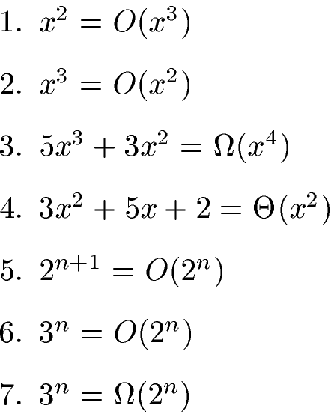

**Solutions:**

1. $x^{2}=O(x^{3})$: We use $c=1$ and $n_{0}=1$ and get: For all $x≥1(our n_{0})$: $x^{2}≤{1⋅x}^{3}$
2. $x^{3}=O\left(x^{2}\right)$: We consider that $x^{3}≤c ⋅x^{2}$ implies $x≤c$. Such $c$ cannot exist because $x$ will always become larger than any constant. Therefore, the **statement is false**.
3. $5x^{3}+3x^{2}=Ω(x^{4})$: We consider that $5x^{3}+3x^{2}≥ c⋅x^{4}$ implies $\frac{5}{x}+\frac{3}{x^{2}}≥c$. Such $c$ cannot exist because the term $\frac{5}{x}+\frac{3}{x^{2}}$ will always become smaller than any constant for increasing $x$. Therefore, the **statement is false**.
4. $3x^{2}+5x+2=Θ(x^{2})$: We require two constants $c_{1}$ (for upper bound) and $c_{2 }$ (for lower bound) as well as the value $n_{0}$. First, we rewrite $3x^{2}+5x+2$ to $x^{2}(3+\frac{5}{x}+\frac{2}{x^{2}})$. For $x=1$, the term $3+\frac{5}{x}+\frac{2}{x^{2}}$ evaluates to $10$ and for increasing $x$ it becomes smaller than 10 but never falls below 3. Therefore, we can choose the two asymptotic constants as follows: $c_{1}=10$ and $c_{2}=3$. For $n_{0}$ we use 1 and get: $3x^{2}+5x+2≤10 ⋅x^{2}$ 
    and $3x^{2}+5x+2≥3⋅x^{2}$ for all $x>1$.
5. $2^{n+1}=O(2^{n})$: We use $c=2$ and $n_{0}=1$ and get: $2⋅2^{n}≤2^{n+1}$ for all $n≥1$.
6. $3^{n}=O(2^{n})$: We consider that $3^{n}≤c⋅2^{n}$ implies $\frac{3^{n}}{2^{n}}={\left(\frac{3}{2}\right)}^{n}≤c$. Such $c$ cannot exist because the term ${\left(\frac{3}{2}\right)}^{n}$ becomes larger than any constant for increasing $n$. Therefore, the **statement is false**.
7. $3^{n}=Ω\left(2^{n}\right)$: We use $c=1$ and $n_{0}=1$ and get: $3^{n}≥{1⋅2}^{n}$ for all $n≥1$ (our $n_{0})$.

# Exercise 2.2

The Max-Heapify algorithm in your textbook has a recursive definition:

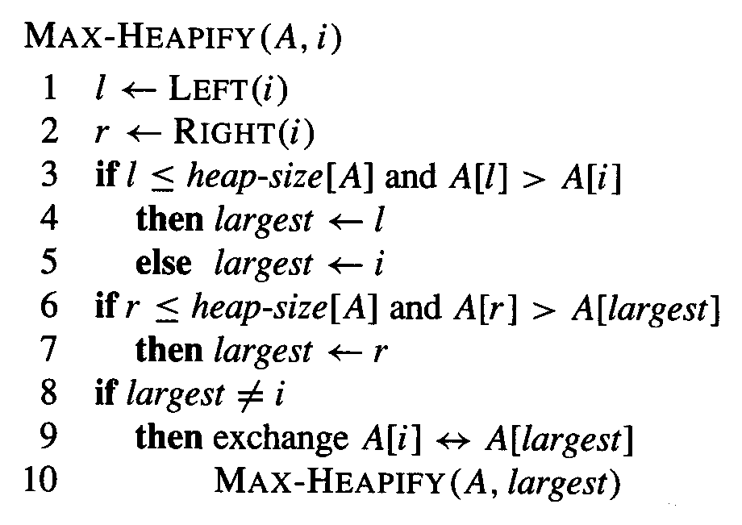

Give an iterative (loop – based) definition of the Max-Heapify algorithm.

**Solution:**

Pseudocode of iterative Max-Heapify:

MAX-HEAPIFY(A, i)

**while** (true)

l = LEFT(i)

r = RIGHT(i)

**if** l<=heap-size[A] and A[l]>A[i]

then largest = l

else largest = i

**if** r<=heap-size[A] and A[r]>A[largest]

then largest = r

**if** largest!=i

then exchange (A[i], A[largest])

i = largest

else break // while loop

# Exercise 2.3

Using Figure 6.4 on page 161 in the textbook as a model, illustrate the operation of Heap sort on the array **A = [6, 12, 1, 28, 7, 19, 22, 8, 2]**

**Solution:**

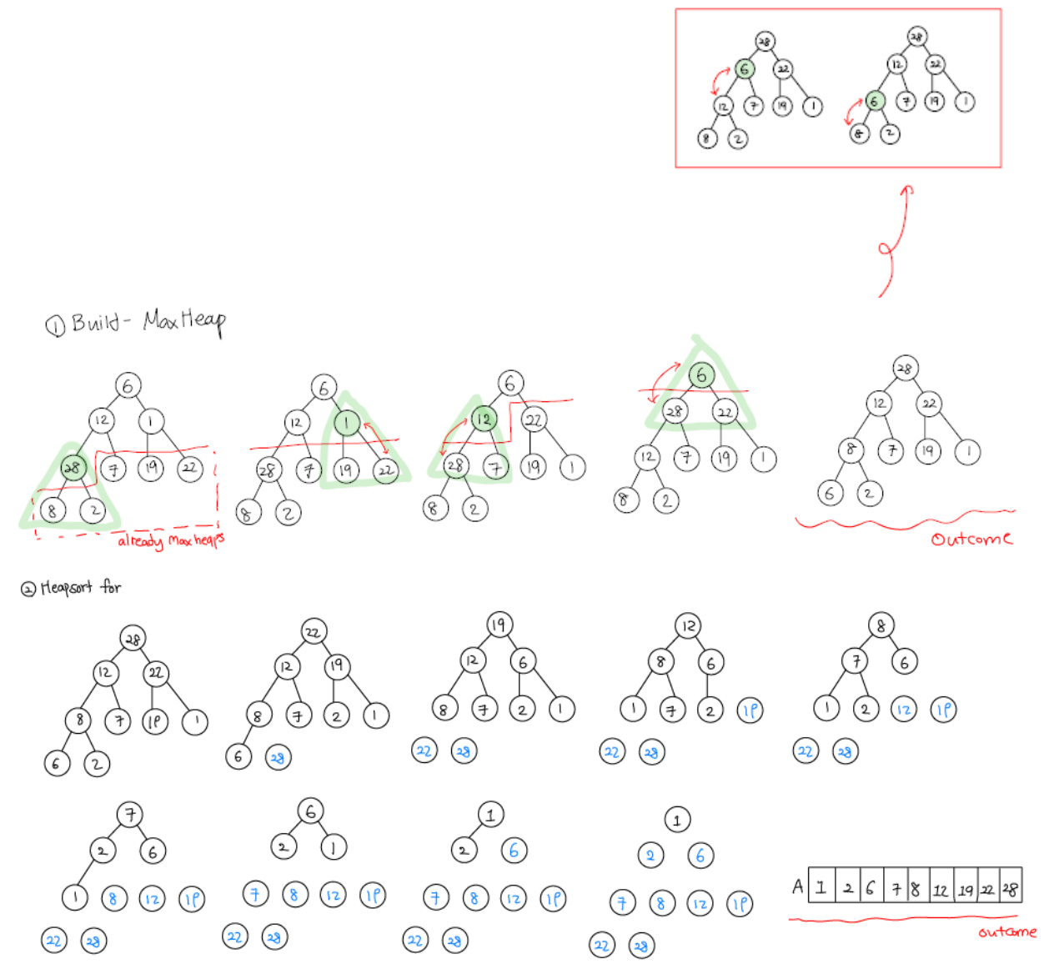(The below figure is copied from the homework report of a participating student of the fall semester course 2020)